**Hall Management System**

**Software Requirements Specification**

**Document**

**TEAM MEMBERS**

**AP18110010269 – B. SPANDANA REDDY**

**AP18110010298 - CH. RUKMINI**

**AP18110010319 - V. POOJITHA**

**1.Introduction**

The main objective of the hall booking or management system is to manage the details of booking dates, booking of hall, customers, and details of halls. It manages all the information about halls, booking of hall and payment and login and creating account of users and admin. The Project is built at administrative end and thus only the admin is guaranteed the access. The purpose of the project is to build an application program to reduce the manual work for managing the payment, booking dates, inventory, booking halls. It tracks all the details about the booking, customers, halls.

**1.1 Abstract:**

Online hall management system is a system software project that serves the functionality of an event manager. The system allows, registered user login and new users are allowed to register on the application. The system helps in the management of events, users and the aspects related to them. This proposed to be a web application. The project provides most of the basic functionality required for an event type e.g. [Marriage, Dance Shows, Birthday parties, College Festival, etc.] the system then allows the user to select date of the event to book a hall and type of the hall. All the data is logged in the database and the user is given an ID number for his booking. The data is then sent to administrator (website owner) and they may interact with the client as per his requirement.

## 1.2 Purpose

The purpose of this online web-based application system can be implemented in hotels, Function halls, colleges, clubs etc. for booking events. The system can also be used as software to promote the entire booking places. The user gets all the resources at a single place instead of wondering round for these. This system is effective and saves time and cost of the user.

**1.3 Intended audience and reading suggestions**

This document is mainly intended for the people who are involved in the development, testing, operation, maintenance and quality assurance of the system. This also helps users and clients in understanding the requirements of the system. Audiences need not follow any particular order while reading the document and they are free to move to any section which they find relevant to them.

**1.4 Project Scope**

The existing method of going to a function hall, booking the hall, waiting for the conformation of hall booking, making payment etc., all these processes require a lot of time and manual work. Also, the maintenance of the records of the bookings and payments is a tedious job. Proposed system aims at solving the problems that are being faced in the existing method. It aims at providing an easy-to-use and convenient system for the customers who are willing to book a hall in online. The records of the payment and bookings are stored in the database automatically when a booking is placed/removed or when a payment is made. To help the customers in improving their quality of communication and attract customers the feedback from the customers can also be stored by this system.

**1.5 Definitions, Acronyms, and Abbreviations.**

SRS – Software Requirements Specification

HMS – Hall management System

End users – The people who will be actually using the system

PHP – PHP: Hypertext preprocessor

**1.6 Overview**

The SRS is organized into two main sections. The first is The Overall Description and the second is the Specific Requirements. The Overall Description will describe the requirements of the HMS from a general high-level perspective. The Specific Requirements section will describe in detail the requirements of the system.

**2. The Overall Description**

Describes the general factors that affect the product and its requirements. This section does not state specific requirements. Instead, it provides a background for those Requirements, which are defined in section 3, and makes them easier to understand.

**2.1 Product Perspective**

The online hall management system would be a web-based application, through which the user can easily book halls of their choice based on events like birthday parties, wedding, kitty parties etc., It can be accessed through any browser like google chrome, Firefox, safari etc., All databases for the HRS will be configured using MySQLDatabase and php. These databases include hall bookings, customer’s information, billing details and other service information n. The end users can modify these.

**2.1.1 Hardware Interfaces**

Operating system: Windows, Linux, Mac

Processor: i3 or above

Hard Disk Space: 40 GB (min.)

RAM Memory: 512 MB (Min)

**2.1.2 Software Interfaces**

XAMPP Software

Apache server

PhpMyAdmin

IDE: Sublime text/Notepad

Browser: Google chrome or Mozilla Firefox or Internet explorer or Microsoft Edge etc..

**2.2 PRODUCT FEATURES AND CHARACTERISTICS**

The hall management system provides the functionalities for the customers to create a account, book a hall, and make a payment.

Such as:

1. Creating an account if new user
2. If account exists login to the system
3. Go to About halls section in navigation bar
4. Details of the halls
5. Navigation through the booking section
6. Adding details to book a hall like name of the customer, type of hall and date of the hall booking for
7. Review their current booking
8. Can also update or delete the booking

**2.3 E-R Diagram**

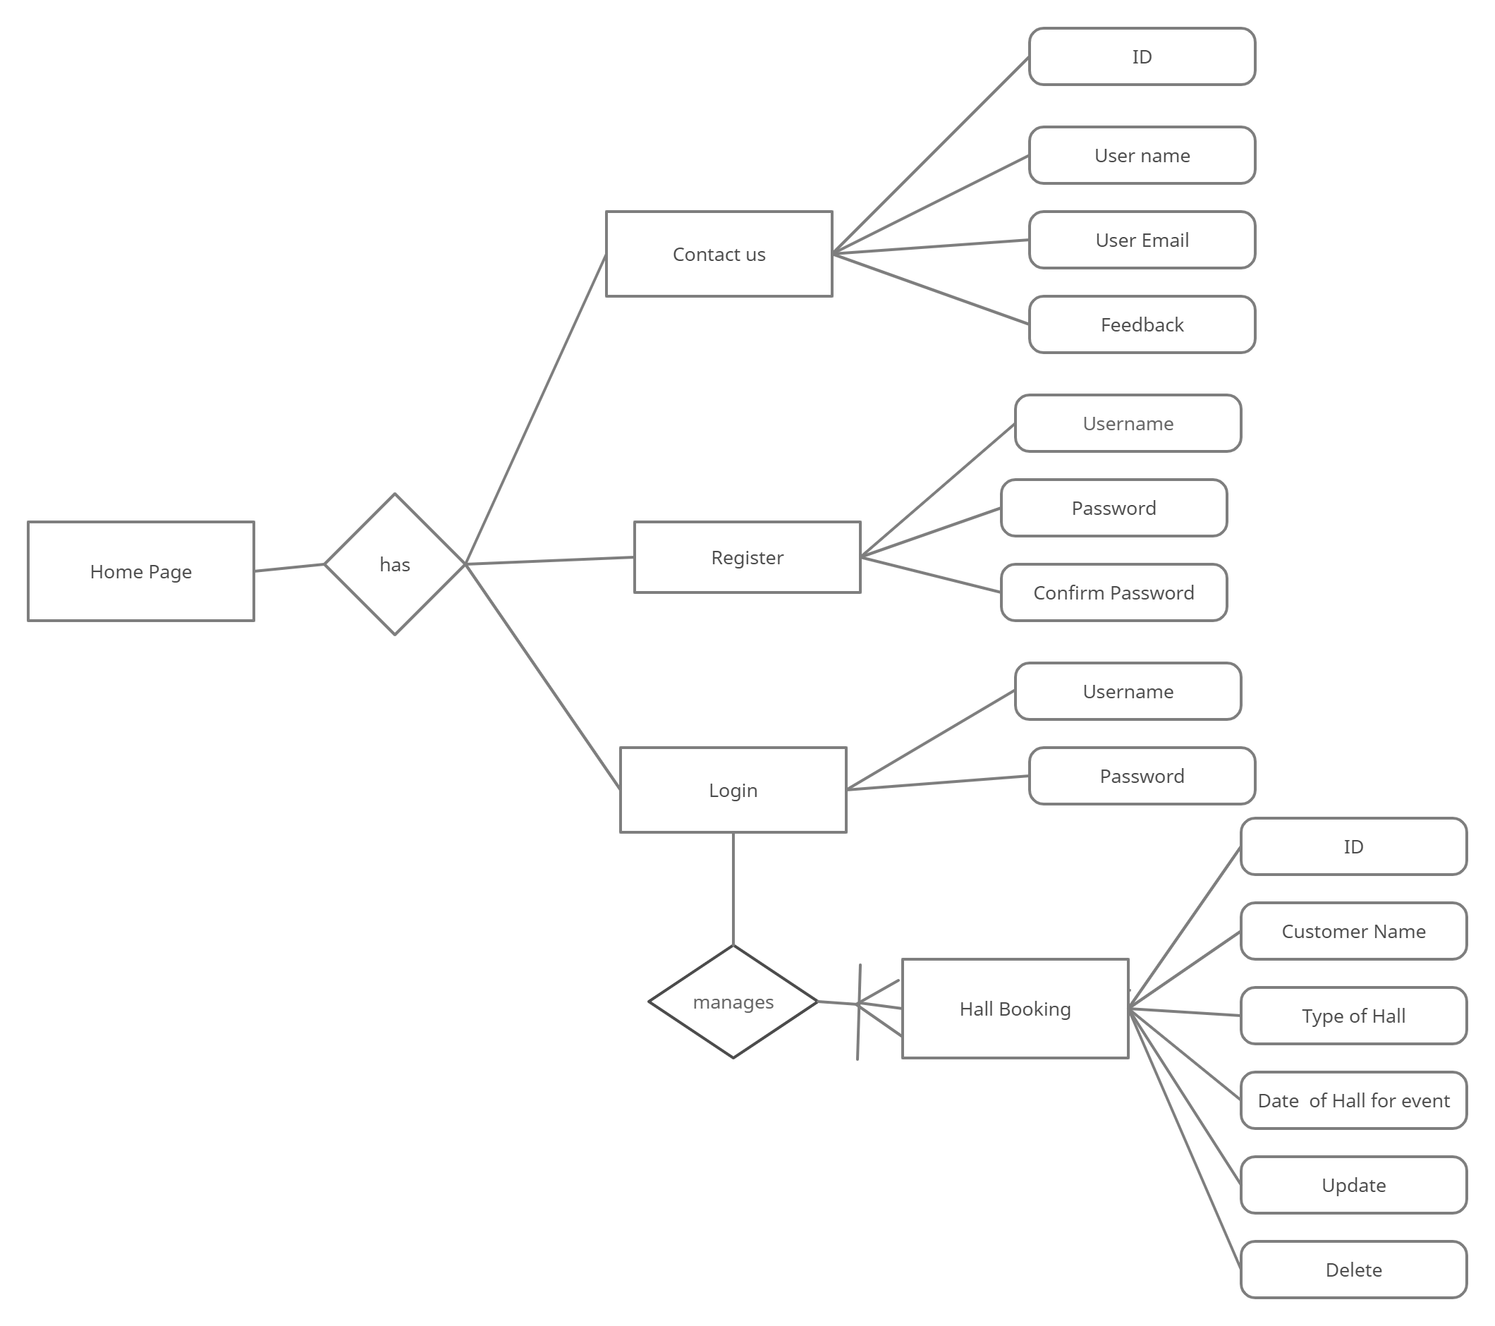

The entity relationship model of the hall management system shows the overall and visual component of the database table and the relation between customer, hall and employee. It is the structured data to define the relationship hall booking system functionalities.

* Hall Booking system entities and attributes:

Login: Username, password

Hall Booking: ID, Customer Name, Type of hall, date of hall for the event, update, delete

Contact us: ID, Username, User email, feedback

**2.4 OPERATING ENVIRONMENT**

Below mentioned are the modules with their description which we have used in our project:

HTML: HTML (Hypertext Markup Language) is the most basic building block of the Web. It defines the meaning and structure of web content. Every web page you see on the Internet is written using one version of HTML code or another.

CSS: Cascading Style Sheets (CSS) is a simple mechanism for adding styles (e.g., fonts, colors, spacing) to Web documents. CSS defines how HTML elements are to be presented on screen, paper, or in other media. CSS saves a lot of work.

PHP: PHP is a server-side scripting language. that is used to develop Static websites or Dynamic websites or Web applications. PHP stands for Hypertext Preprocessor, which earlier stood for Personal Home Pages.

MySQL: MySQL is a relational database management system based on SQL – Structured Query Language. The most common use for MySQL, however, is for the purpose of a web database.

XAMPP SERVER: XAMPP is a software distribution which provides the Apache web server, MySQL database. It is available for Windows, MAC and Linux systems.

**3.SYSTEM FEATURES**

**3.1 FUNCTIONAL REQUIREMENTS:**

This is how the device will appear and function until it has been successfully completed.

The functional criteria must be met by the system are as follows:

1.Users:

When a customer visits an online hall management system, he will be asked to login or register for a better experience. A separate username and password must be created by the customer. The information such as name of the person, type of hall and date of the hall want and details must be filled by the customer. The customer can update the details of the booking or can cancel the reservation of the booking.

2. Administrators

* The administrator must be able to log in and out.
* The administrator must be able to add/delete/edit other users.
* The administrator must be able to view an reservation details of all the customers.
* Only users with respective rights (administrators) must be able to use all these “Admin” features

**3.2 NON-FUNCTIONAL REQUIREMENTS:**

A non-functional requirement is a requirement that specifies criteria that can be used to judge the operation of a system, rather than specific behaviors.

Some of the non-functional requirements include:

* There should be sufficient network bandwidth
* Backup- provision for data backup
* Easy to maintain
* Performance/ response time- fast response
* Usability by target user community- easy to use
* Expandability- needs to be future proof or upgradable
* Safety- should be safe to use

**3.2.1 PERFORMANCE REQUIREMENTS:**

Performance requirements define acceptable response times for system functionality.

* Performance should be fast
* Performance will depend up on hardware components
* The load time for user interface screens shall take no longer than two seconds.
* The log in information shall be verified within five seconds.
* Queries shall return results within five seconds.

**3.2.2 SAFETY REQUIREMENTS**

* Data in the database of the system should not be lost or damaged.
* The source code developed for this system shall be maintained in configuration Management tool.
* If there is extensive damage to a wide portion of the database due to some failure, such as a disk crash, the recovery method restores a past copy of the database that was backed up to archival storage and reconstructs a more current state by reapplying or redoing the operations of committed transactions from the backed-up log, up to the time of failure

**3.2.3 SECURITY REQUIREMENTS**

* Secure access of confidential data. (customer information).
* The whole system is secured. Only admin can access all the database at any time.
* This system will use HTTPS so it is more secure.
* This system will use a secured POS system.

**3.2.4 SOFTWARE QUALITY ATTRIBUTES**

**Availability:**

The online hall management website will be available to users at any time except when the server is lost or bad internet connection or when having some errors.

**Robustness:**

If the connection between user and the customer is broken or disconnected prior to a booking of hall either conformed or cancelled, the online hall management system shall enable the user to recover an incomplete booking of the hall.

**Platform Independence:**

The system must have to run on different platforms and support different types of database management systems.

**Extensibility:**

The system must be easy to extend to provide new capabilities.

**4. EXTERNAL INTERFACE REQUIREMENTS**

**4.1 User Interfaces:**

The system has to allow the user or admin to interact with different modules which are having in web application such as login in to the account, creating the new account, logout from the session, booking the hall etc., The project will support all types of web browsers and the interface provided to the user is user-friendly and convenient to us.

**4.2 Hardware Interfaces:**

A laptop having good and high-speed internet connection with windows operating system with any browser. To deploy, the project administrator should have a system with a minimum of 4gb ram and intel i3 processor and hard disk of 1TB.

**4.3 Software Interfaces:**

The system shall interface with a MySQL for creating and updating the database. In database data is stored and related to users are booking of hall, conformation and payment etc.

**4.4 Communicational Interfaces:**

The system will show the details of booking like conformation of the booking.

**5. UML Diagrams**

**5.1 Use Case Diagram**

**Online Hall Management System**

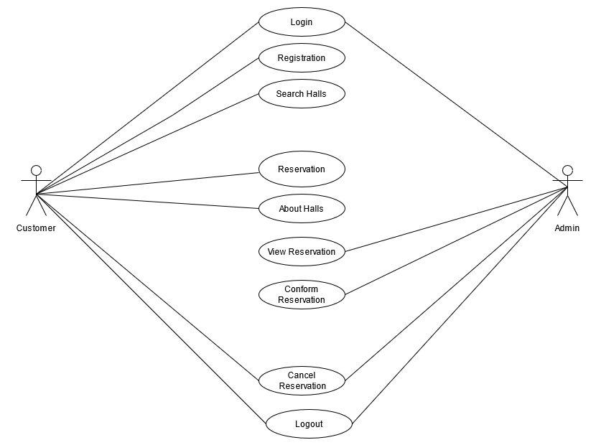

**5.2 Class Diagram:**

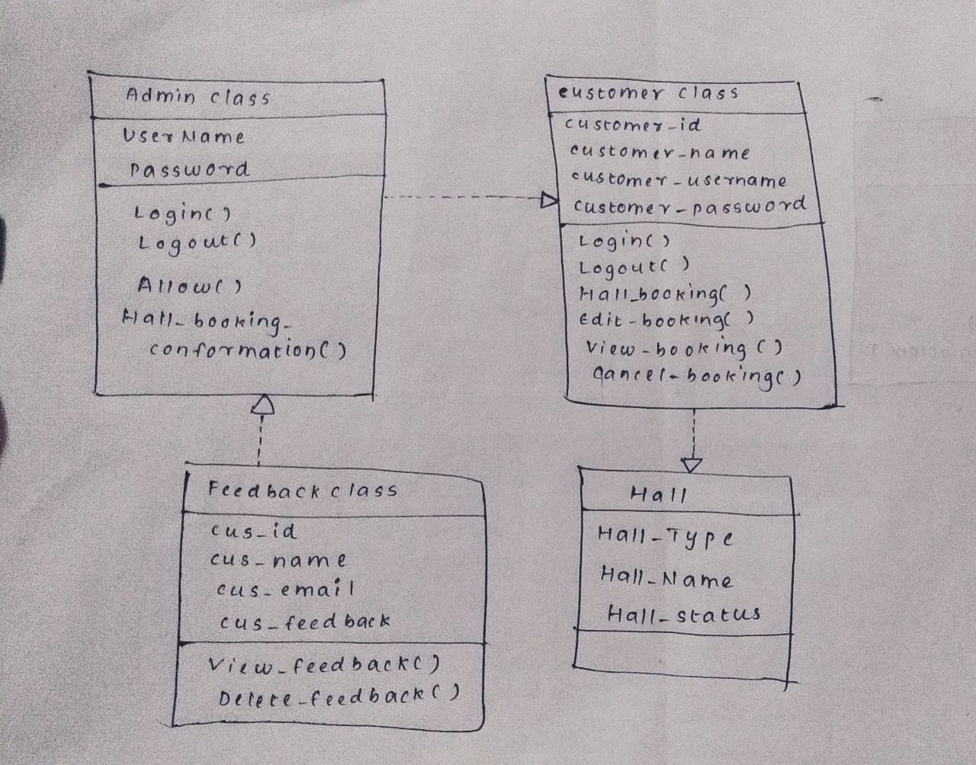

**5.3 Activity Diagram:**

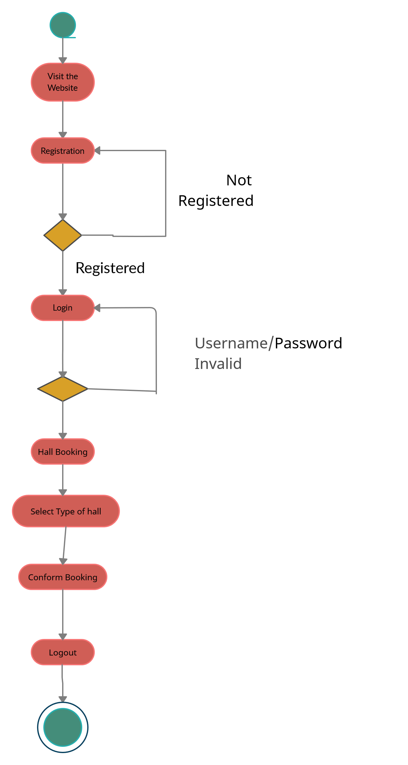

**5.4 Data flow diagram:**

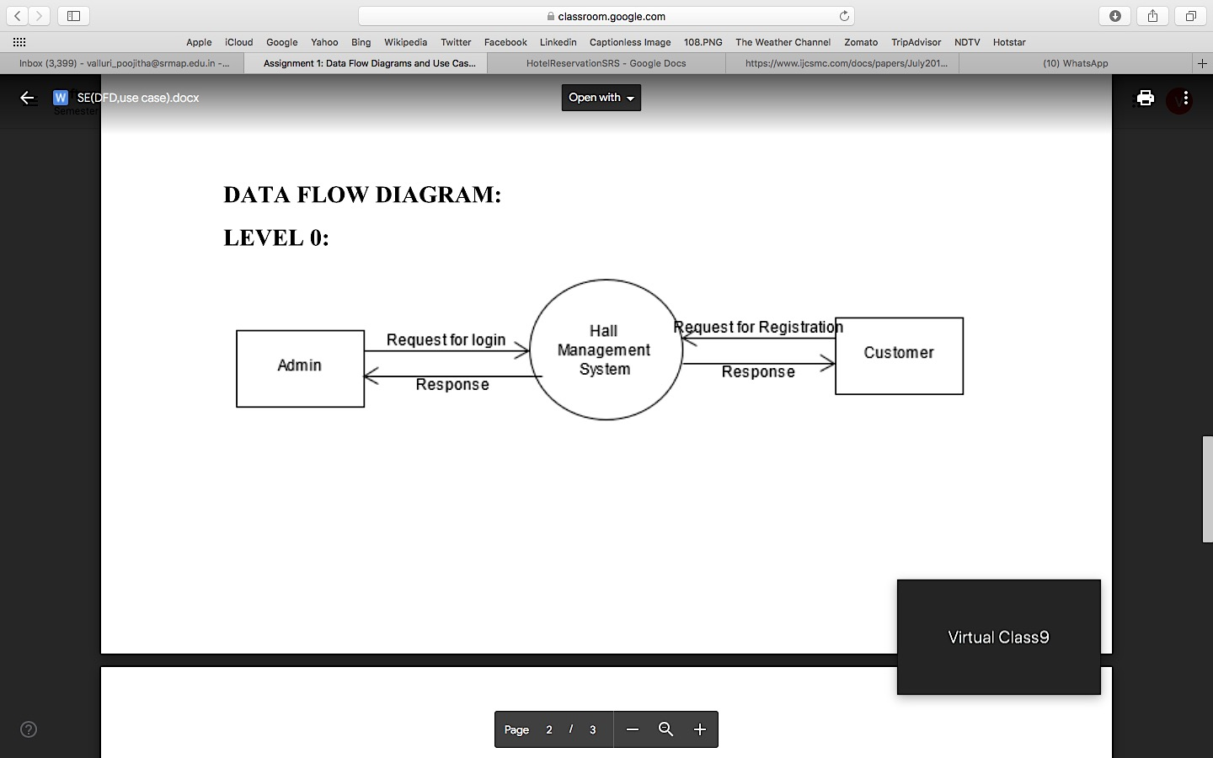

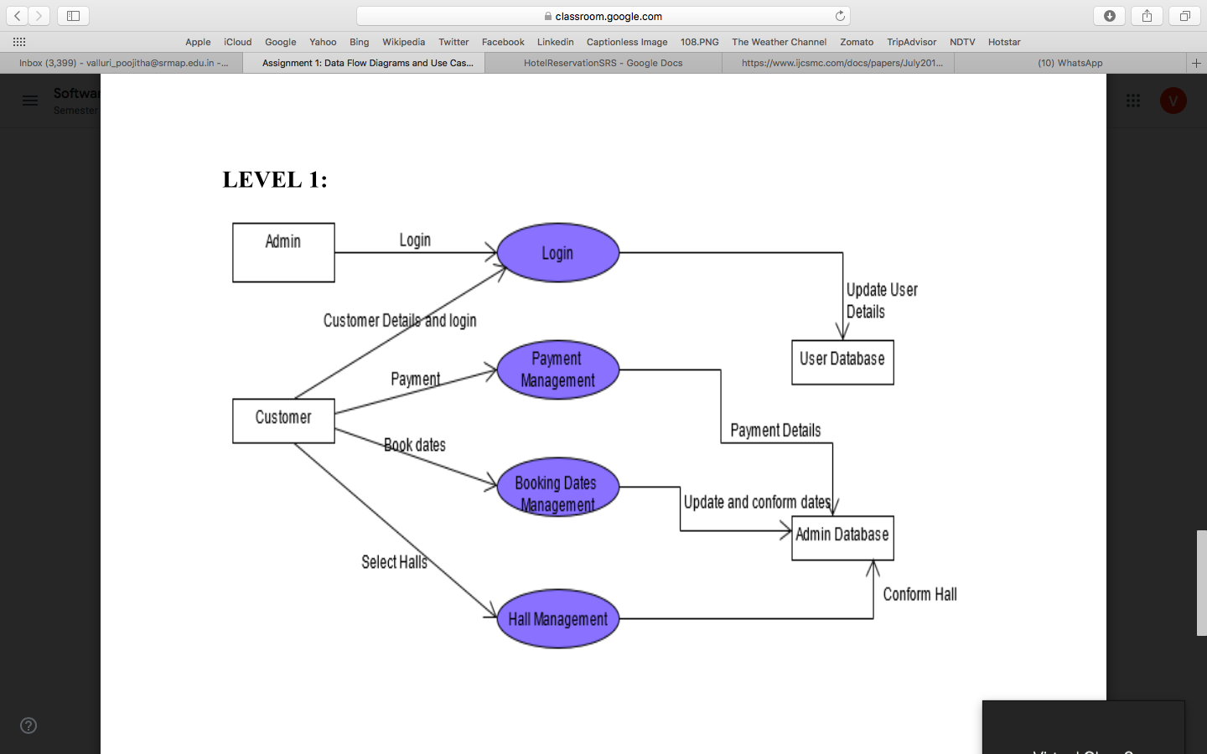

**5.5 Sequence Diagram**

**Login Sequence Diagram of Hall Booking**

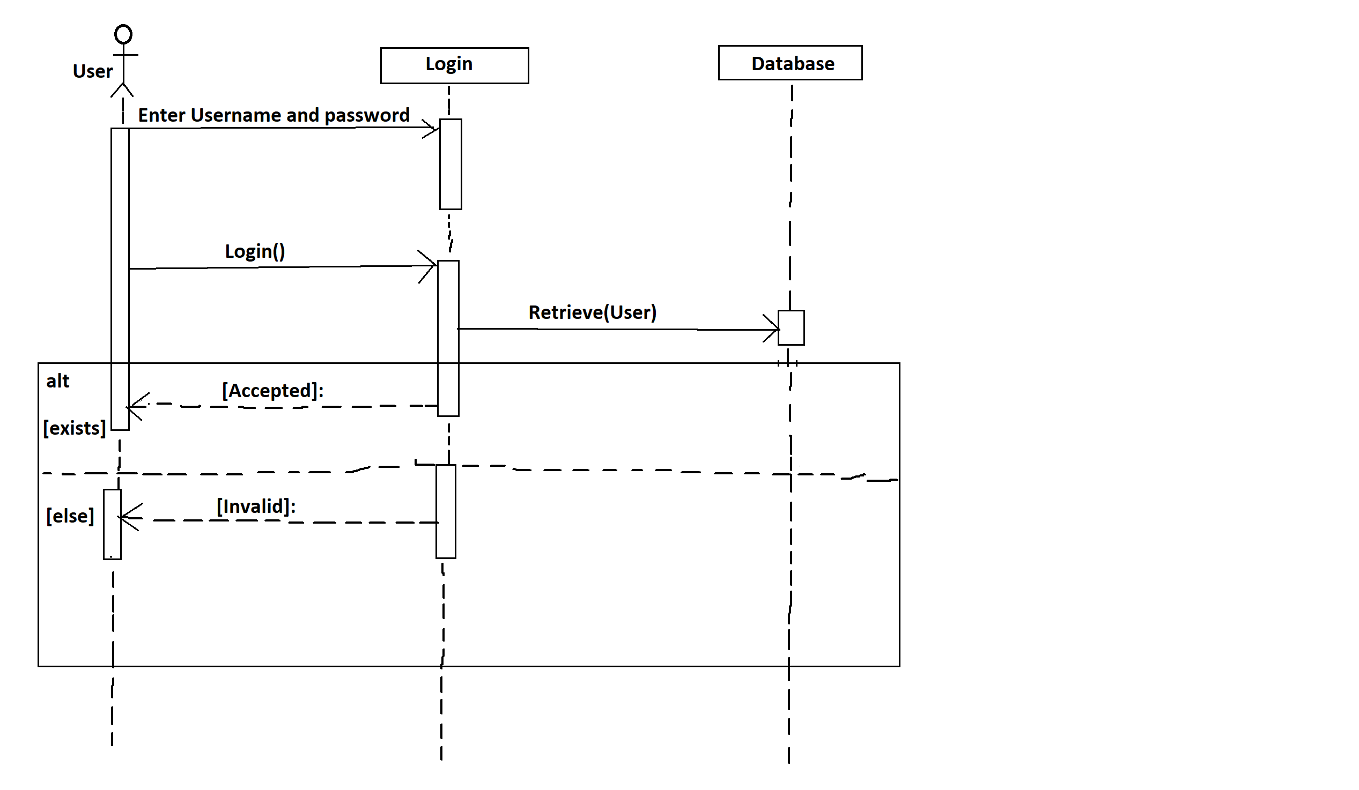

**UML Sequence Diagram of Hall Booking**

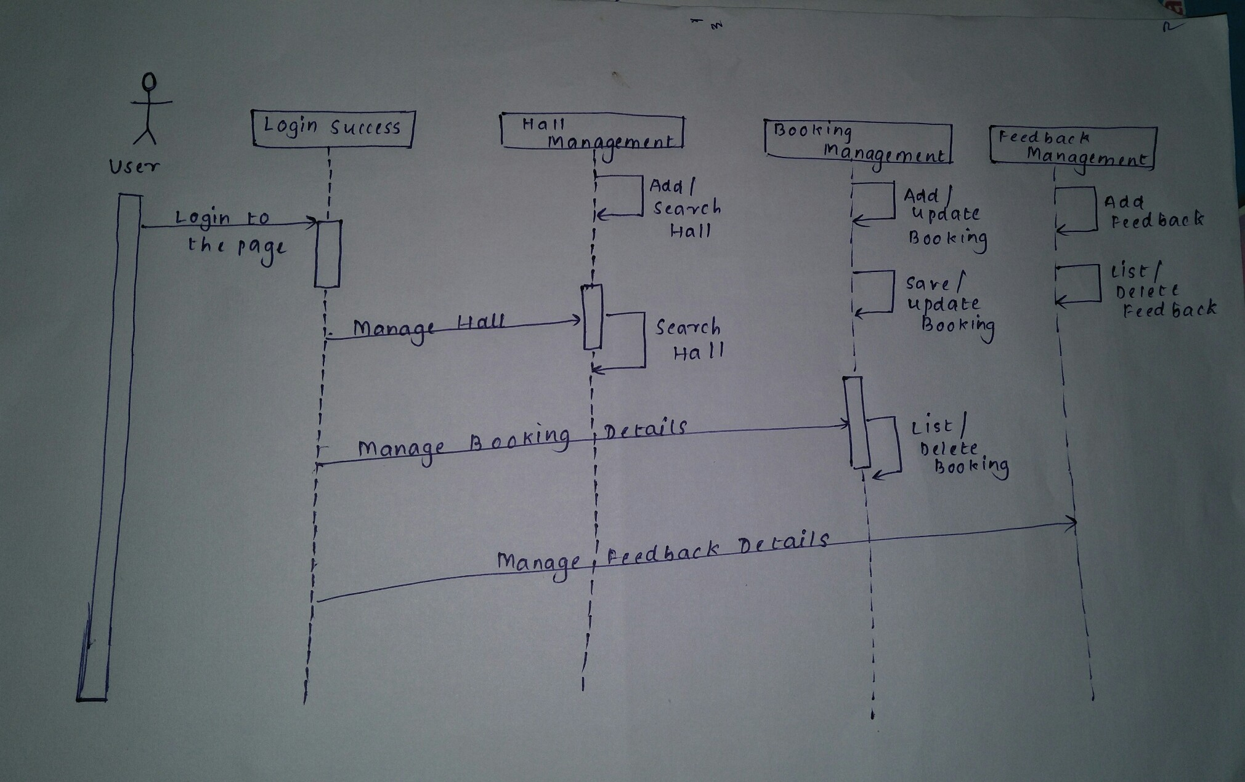

**5.6 Object Diagram:**

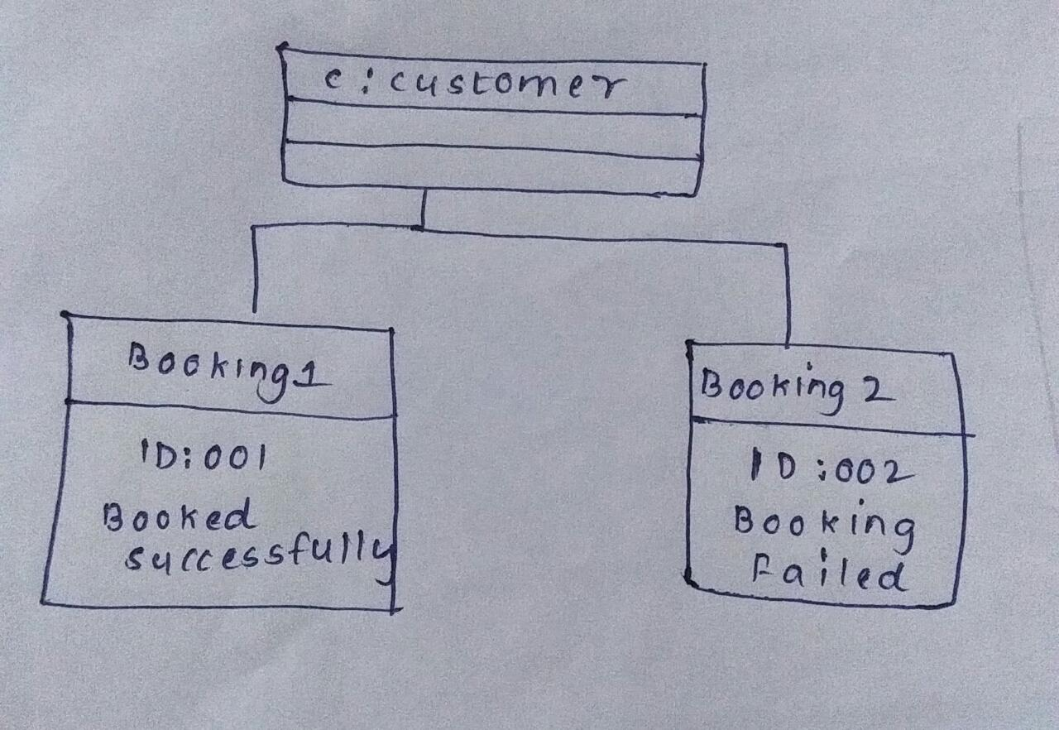

**5.7 State Chart Diagram**

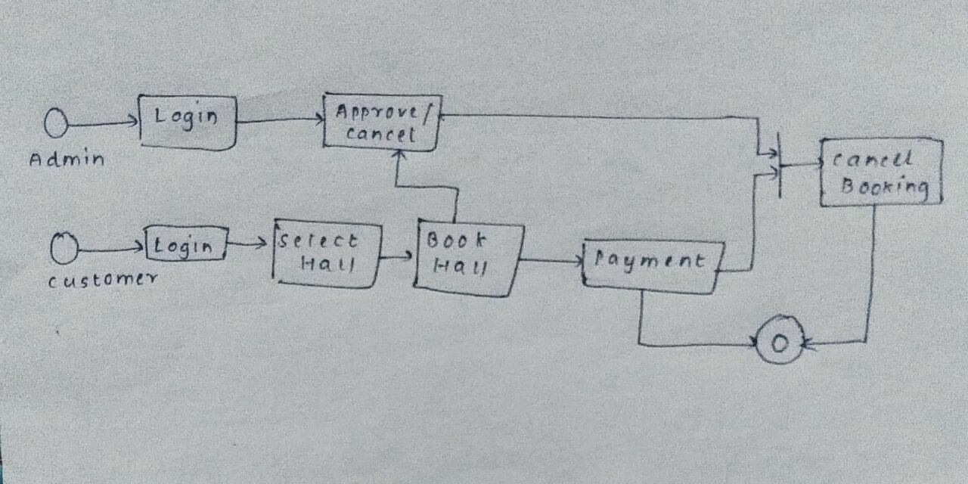

**5.8 Deployment Diagram**

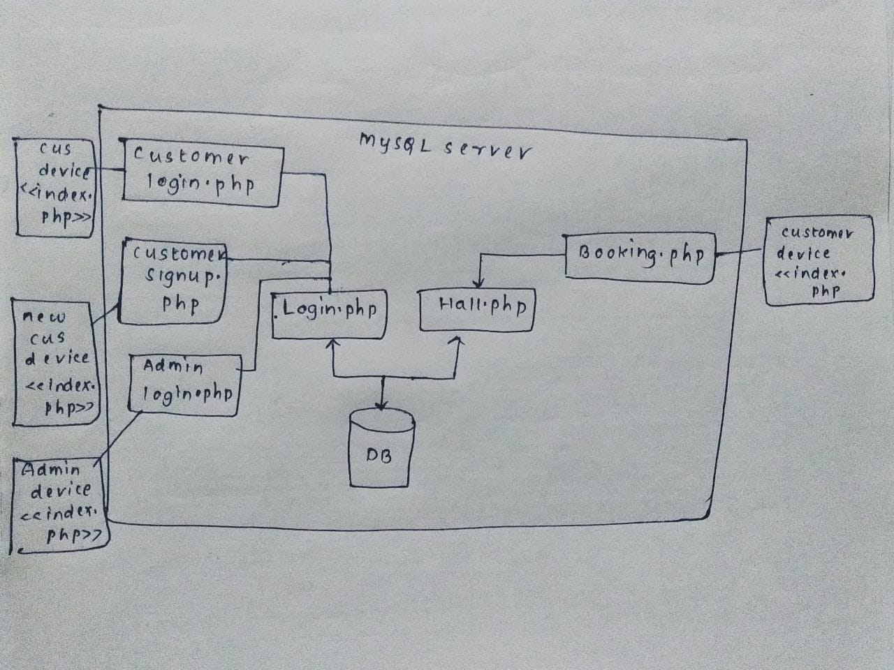

**Project Output Screenshots:**

**Main Page**

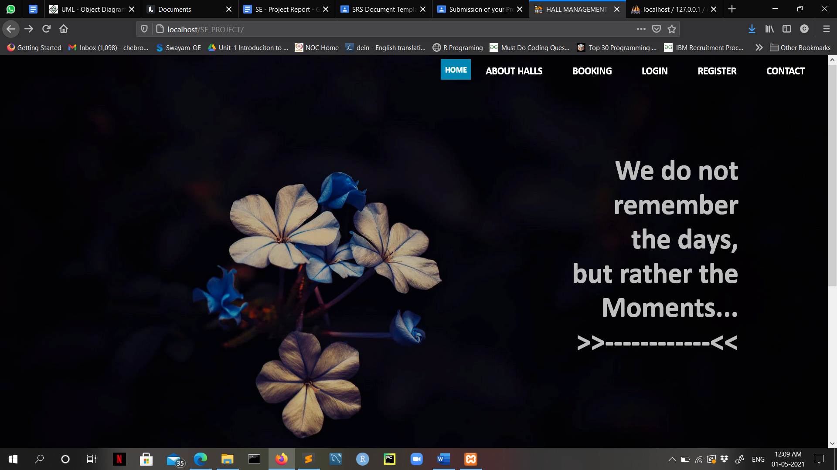

**Creating Account**

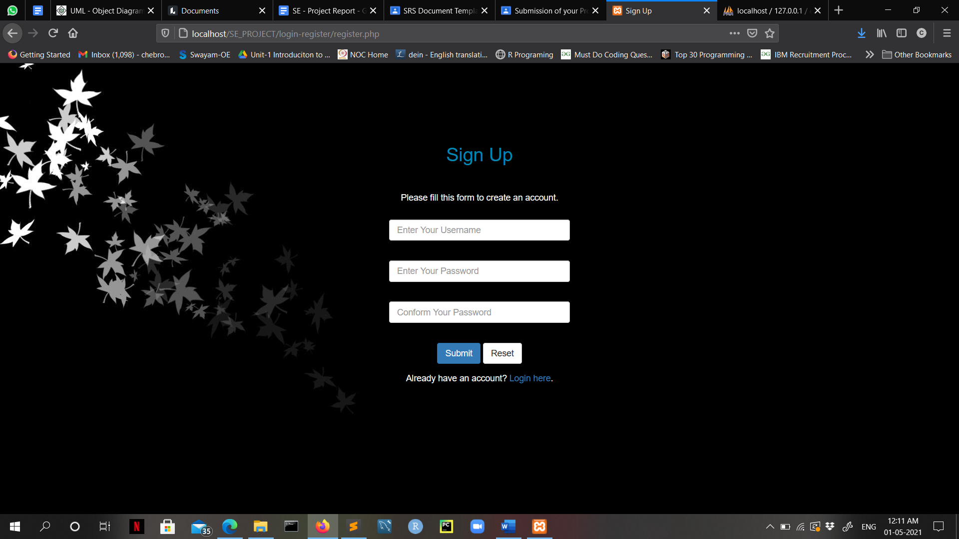

**Login Account**

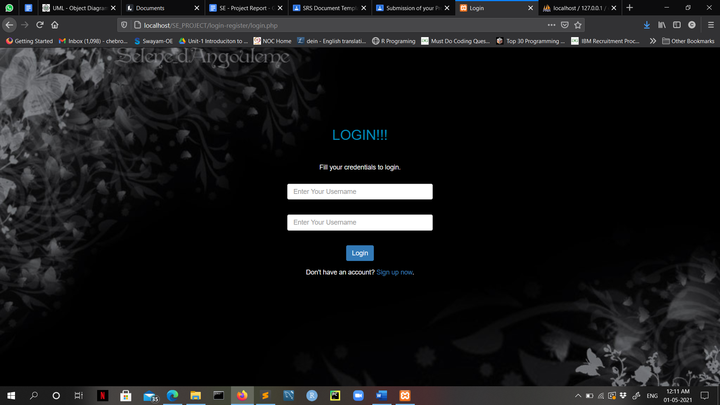

**After Login a page will open to sign out account or book a hall options will be available**

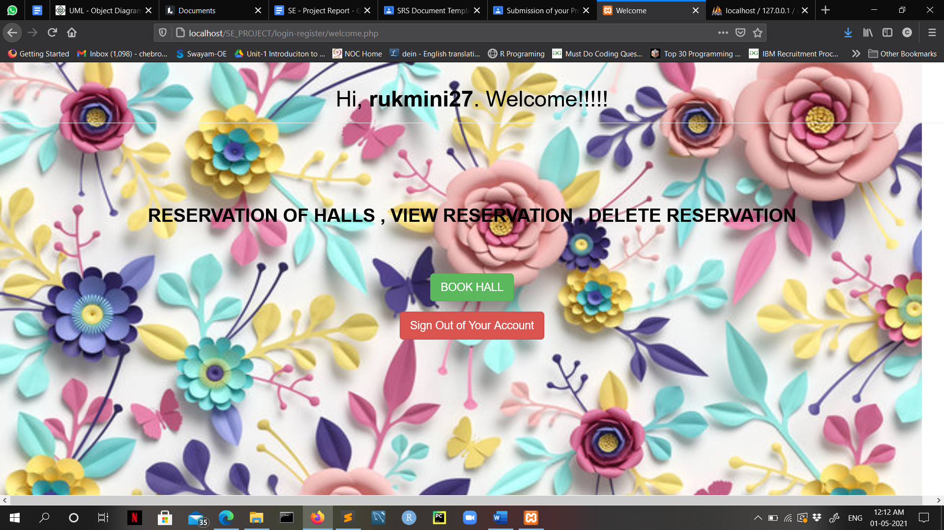

**Booking a hall**

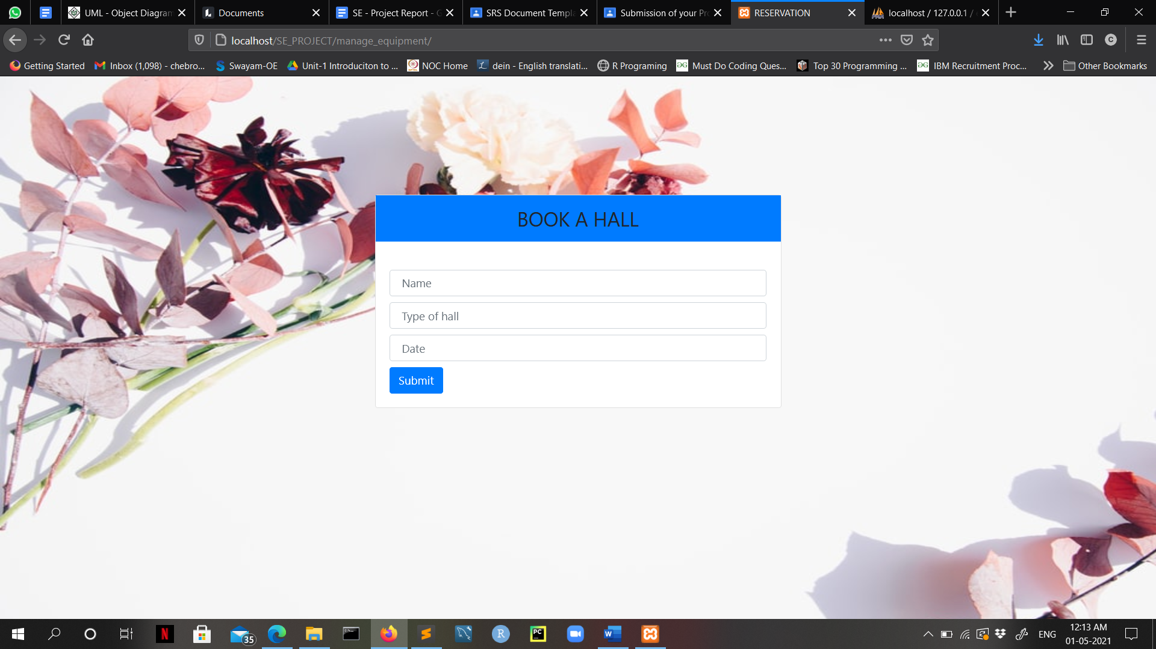

**View, Update, Delete of booking**

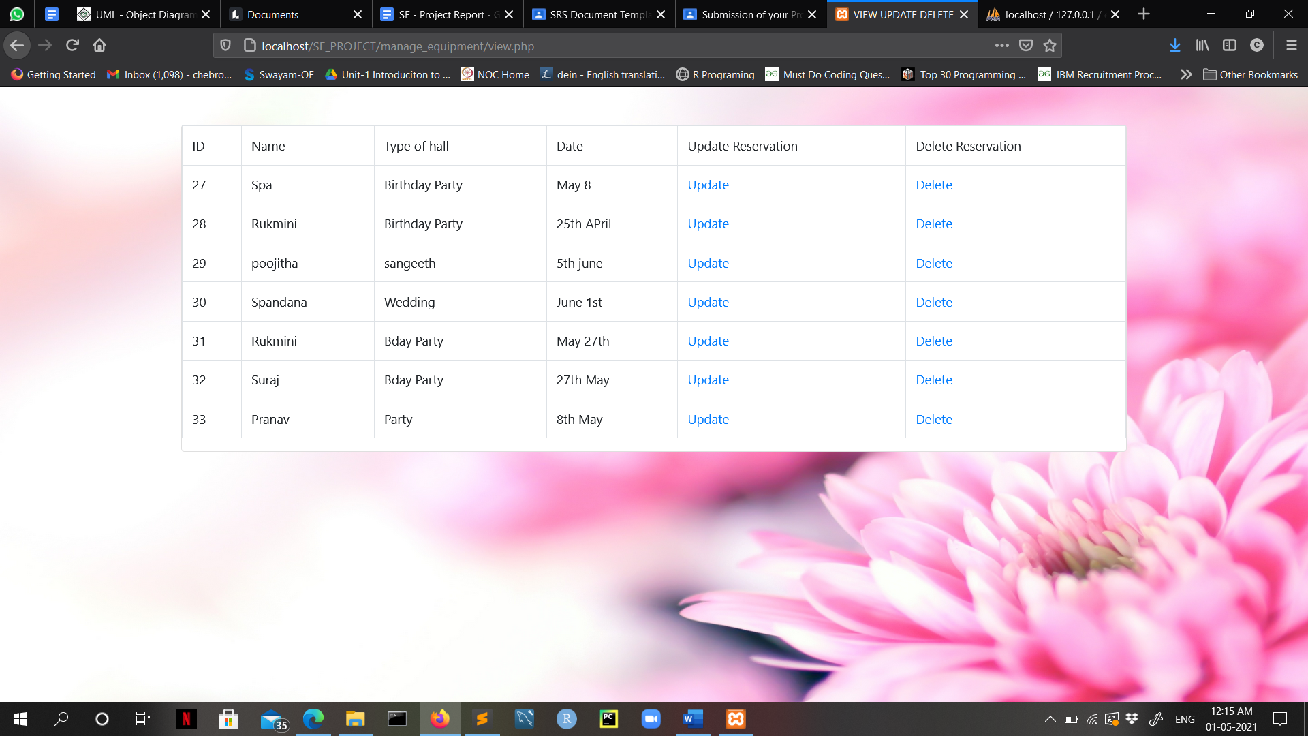

**Hall Details**

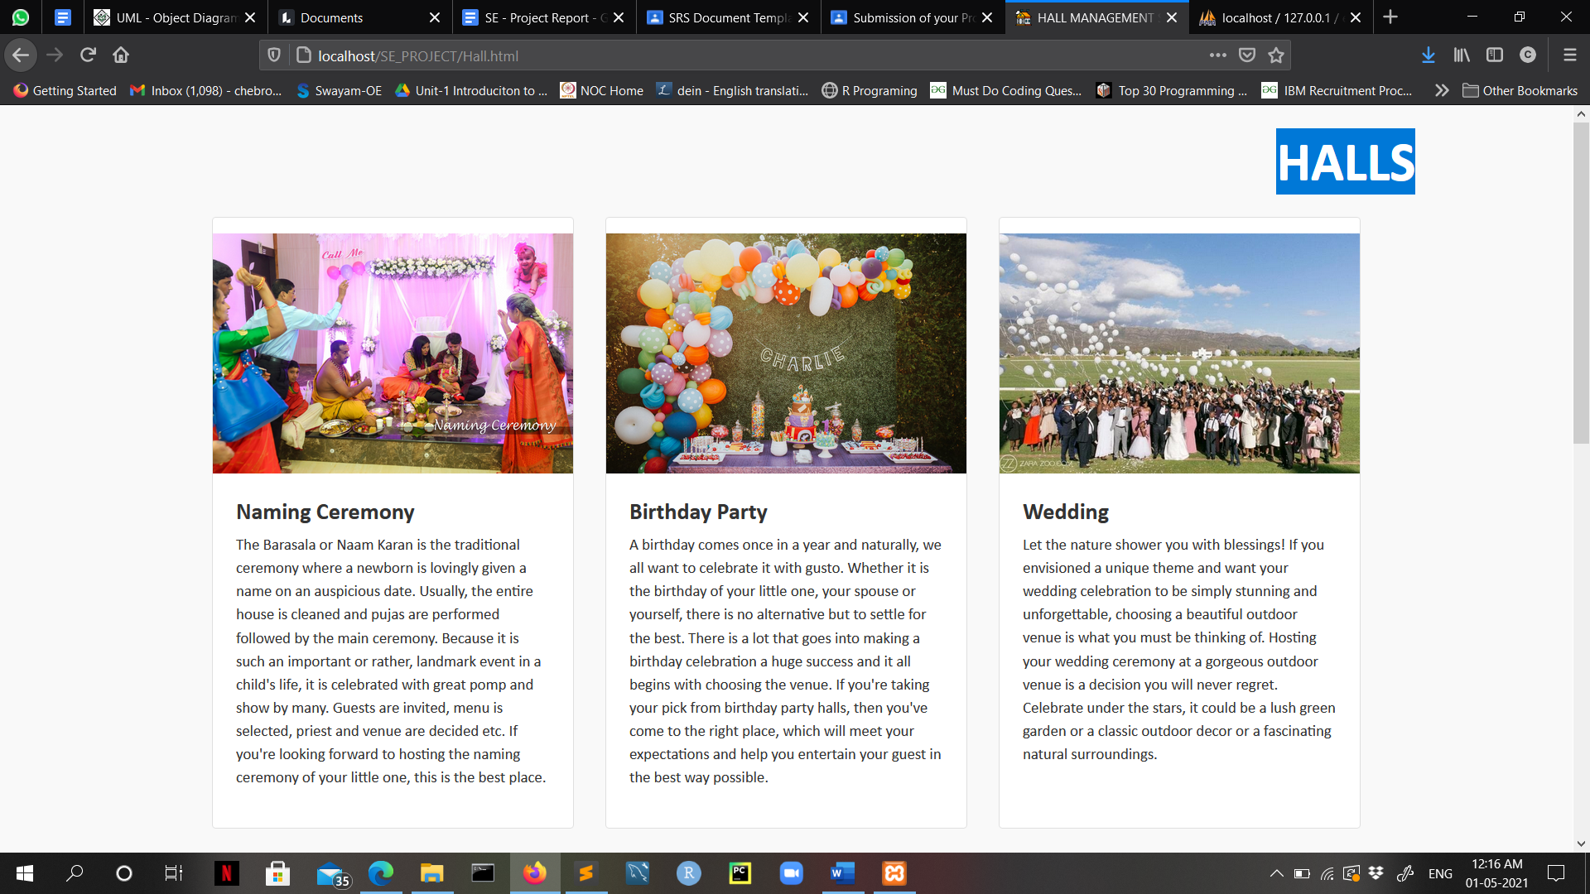

**Feedback Page**

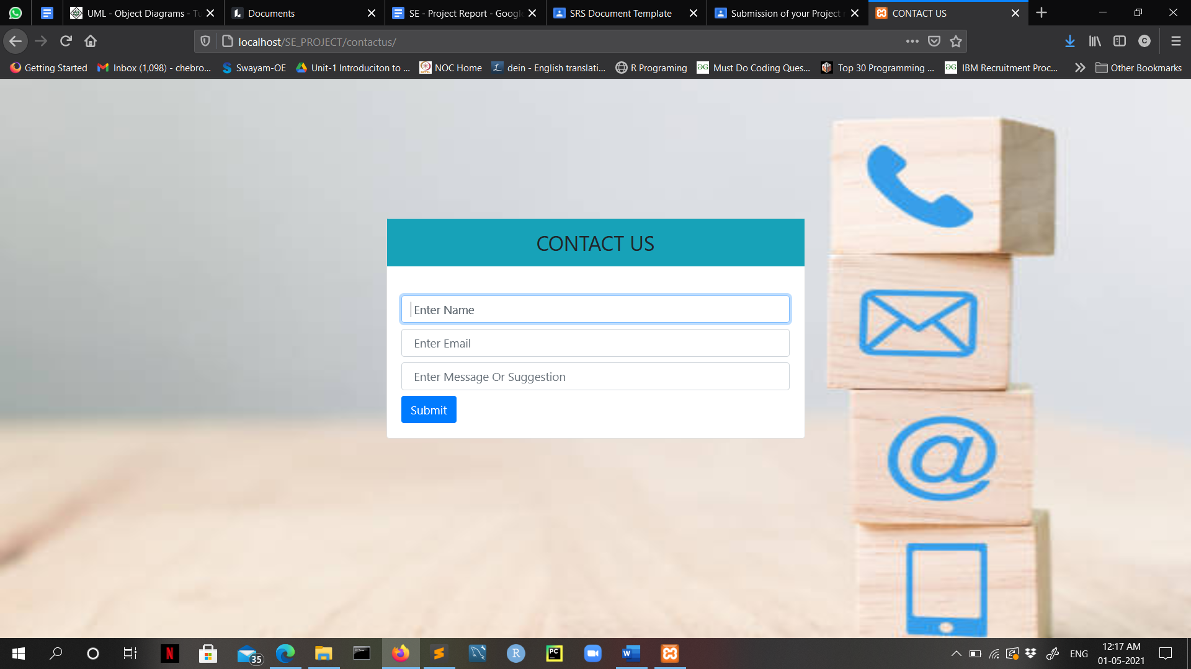

Testing the web-application with **SELENIUM**:

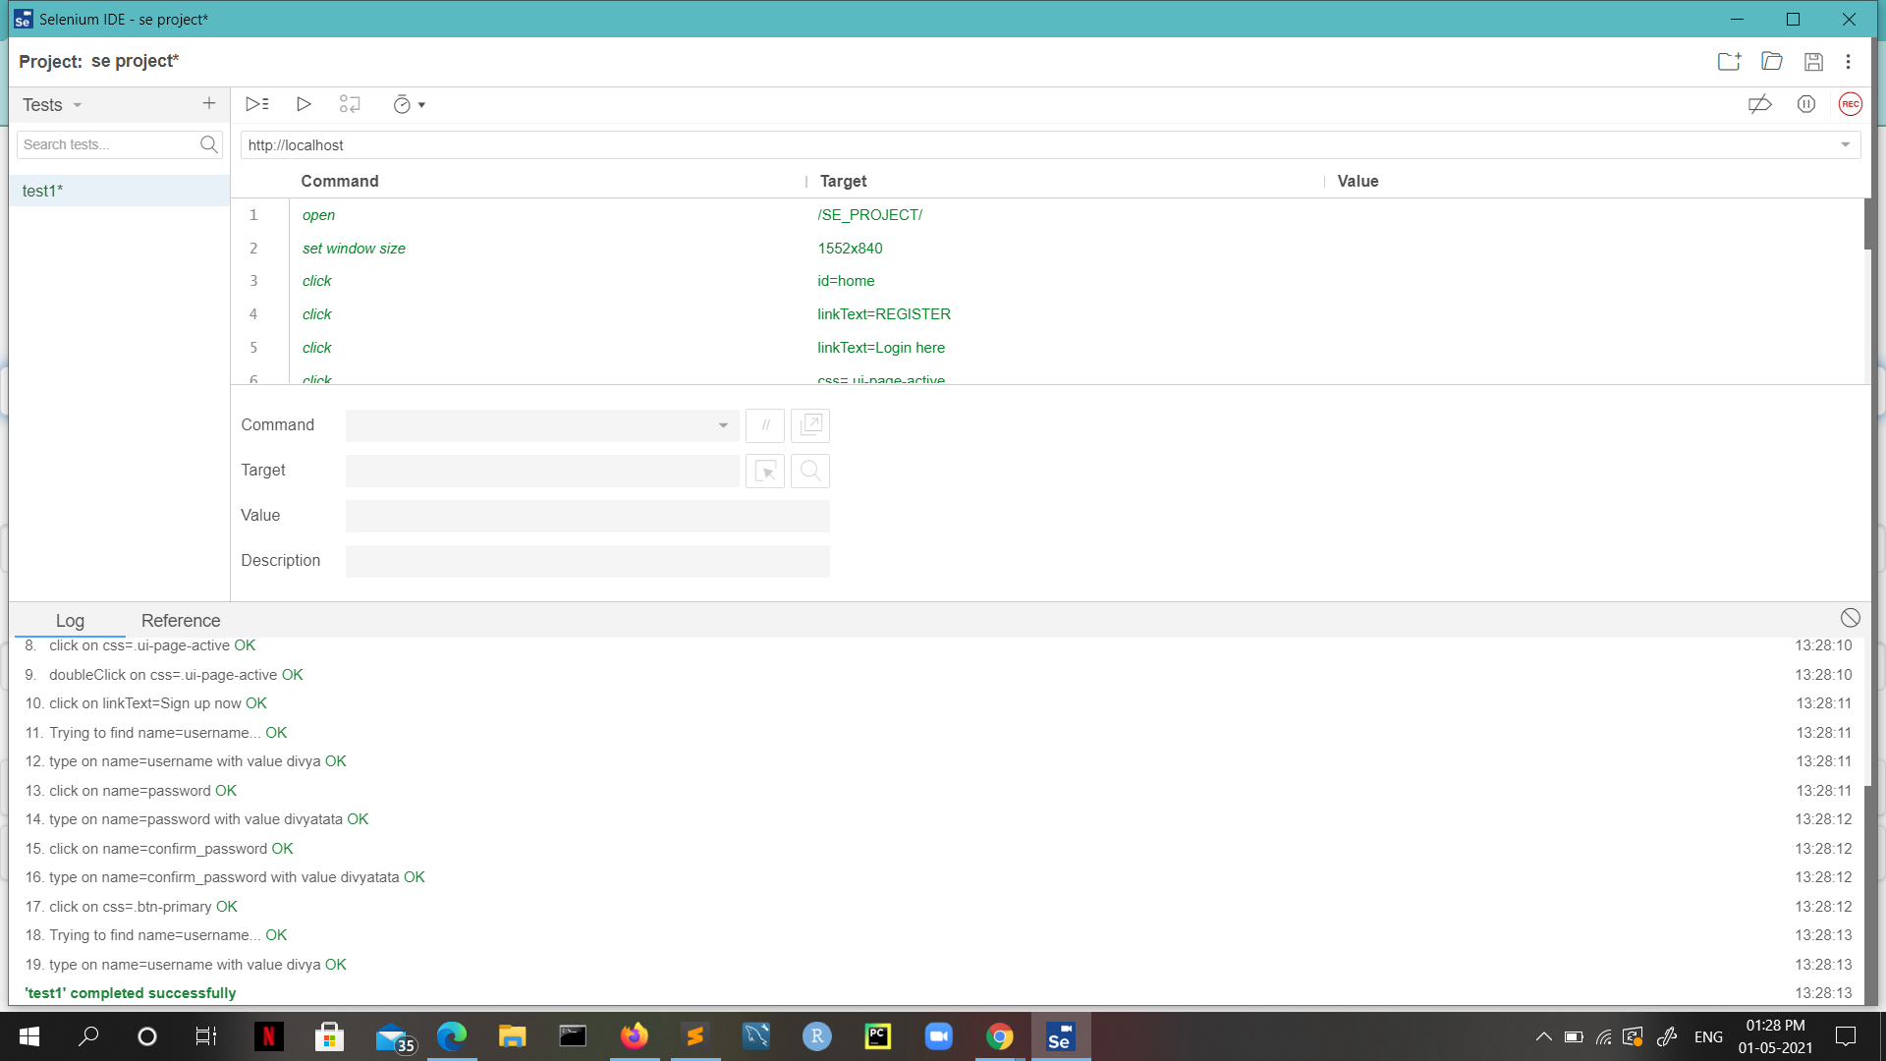

**6.CONCLUSION:**

In this project, we made attempt to effectively introduce the concept of hall management system already existing in the society. We then explain the concept of online hall management systems which are already present. We describe the proposed system and explain the features implemented by our proposed system. We also give a brief overview of the technologies used during the development of our proposed system. This project can be further refined and extended by introducing new and more innovative features.